

CSE PROJECT REPORT

Teacher’s name – Dr. Malvinder Singh Bali

(CSE-326)

Submitted by:

|  |  |  |
| --- | --- | --- |
| S No. | Name | Registration no. |
| 1. | Thota Mohana Naga Venkata Kalicharan | 12304694 |
| 2. | Mamilllapalli Abhiram | 12304943 |
| 3. | Peddineni Chandra Vardhan | 1230 |

**INDEX**

|  |  |  |
| --- | --- | --- |
| **S.NO** | **DESCRIPTION** | **PG.NO.** |
| 1 | Introduction | 2-4 |
| 2 | Technologies Used | 5-7 |
| 3 | Snapshots | 8-12 |
| 4 | Modules | 13-16 |
| 5 | Conclusion | 17 |

**Project Report:**

**Web Page On: Online E-Commerce Store.**

# **Title Page:**

**Web Page on Medical Appointment Booking-WellCare**

**Introduction:**

The online platform for medical appointments serves as the convenient hub connecting users with a wide array of the healthcare services. Through an intuitive interface, patients can effortlessly schedule appointments, manage their healthcare needs, and receive timely reminders. The website streamlines the entire process, from selecting medical services to the confirming appointments, providing a seamless healthcare experience. With features such as real-time appointment tracking and patient reviews, it enhances user satisfaction. This report delves into the website's functionality, user experience, and the impact of technological integration on the evolving landscape of online medical services. Our goal was to create a user-friendly platform that facilitates easy navigation, all while incorporating a theme that resonates with the medical field.

**Index Page:**

The index page is a comprehensive display of the Wellcare hospital website, featuring a navigation bar, many sections in the nav bar they are Home, About, Service, Doctors, Departments, Blog, Book. Every sections has their own use. In every particular sections mentions the speciality of our hospital and we have logo of our hospital in the index page and the image of the doctors, search option in the index page. This all items comprises the Index page

**CSS Styling**

The CSS styling enhances the visual appeal of the pages, employing a clean and modern design. It defines fonts, sizes, and colors for different elements, ensuring consistency throughout the website. The navigation bar is styled for easy navigation, and product images have interactive features on hover.

Overall, the combination of HTML, JavaScript, and CSS creates a user-friendly and aesthetically pleasing environment for visitors to explore and interact with the WellCare hospital website.

**Technologies Used:**

1. HTML (Hyper Text Markup Language)
2. CSS (Cascading Style Sheets)

**Features of Project:**

In this website we will get the Medical appointment Booking. This medical appointment booking is in the main hospital named WellCare. This WellCare hospital website gives the user interactivity with the patients.

**1. User friendly interface:**

Dive into the features of the WellCare hospital website. You can get the service 24/7. This website is made up of the friendly interface. In which you can understand the every part of our website. In the navigation bar you can get link to every section of the website. If you want to go into the Doctors section it is available website you can click the Doctors link in the Navigation bar.

**2. Effortless Navigation: Less time appointment booking is provided:**

Navigating the wellcare hospital website is very much easy to the patients or customers. You can go into sections easily there are many sections in the navigation bar it self, Home section gives you the home page, About page can be viewed by clicking in to the about link available in the navigation bar, Service page can be viewed by clicking in to the about link available in the navigation bar, Doctors page can be viewed by clicking in to the about link available in the navigation bar, Departments page can be viewed by clicking in to the about link available in the navigation bar, Blog page can be viewed by clicking in to the about link available in the navigation bar, Book page can be viewed by clicking in to the about link available in the navigation bar

**3.Resposive Web Designing:**

The website is designed to be responsive, ensuring optional viewing in the webpages in many devices, the web designing used in the website done by the technologies called HTML5, CSS, JavaScript. This technologies make the website to be more responsive in the real-time. Many things in website is been clearly specified as per the customer reviews and interaction. Thus we can say that our website is more responsive. So we call our website as Responsive Webdesigning.

**4. Real-Time Appointment booking Keeping You Informed Every Step of the Way**

Appointment booking in this website is very easy and can be done in few steps. At first we should go to the home page, In the navigation bar you can see a option named Book, click the link book and it will redirect you to the booking page. In the booking page you should enter your name, email and the health issue you are suffered.

**5. Customer Support: Your Dedicated Companions on the Medical journey:**

In this website we have provided our email and you can give the suggestions and the reviews and the improvements should be done in the website. By reading the reviews we can improve the website and the facilities in the hospitals and the modifications done on the hospital. By this way we can say that our hospital website is more dedicated to the customer services.

**6. 24/7 Accessibility in the website:**

Our website gives access 24/7. You can access the website every time when you want it, our website says if you had any fear regarding the health issue then don’t fear our WellCare hospital website is there. This will reduce the time of waiting at the hospital and we can give our best customer care at the customer desk.

**Some Screenshots of the Project:**

**1.Main page:**

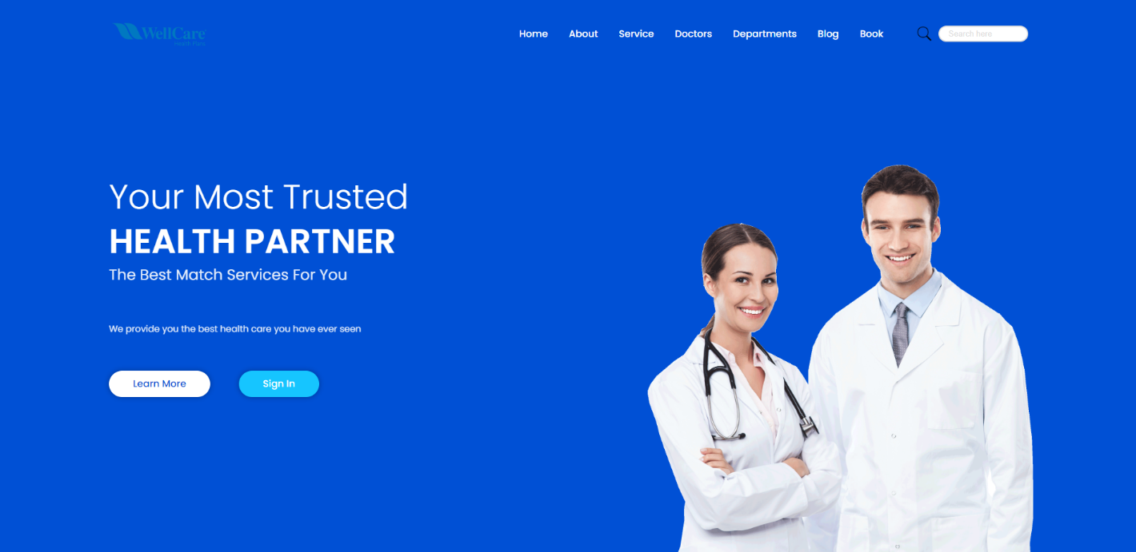

**2.About page:**

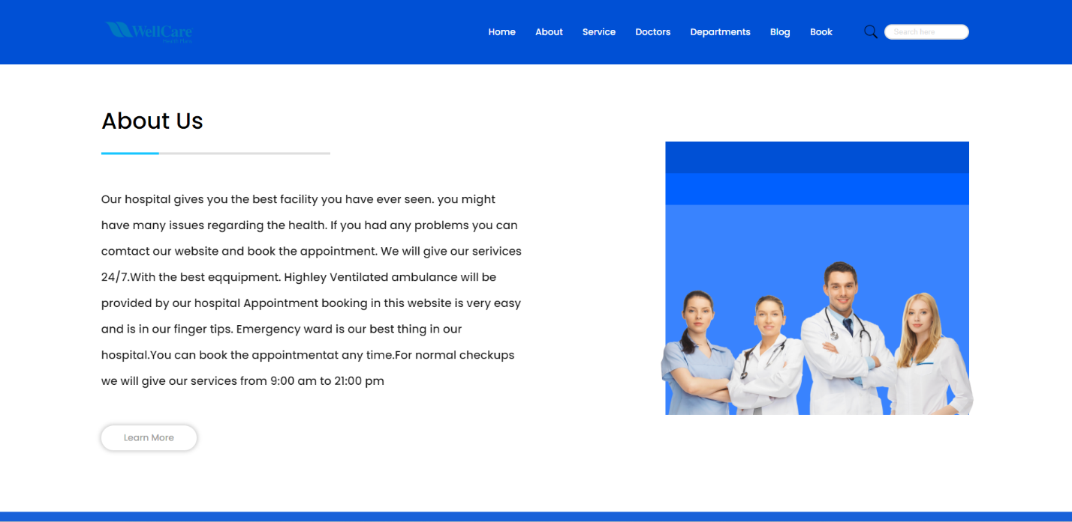

**3.Services page:**

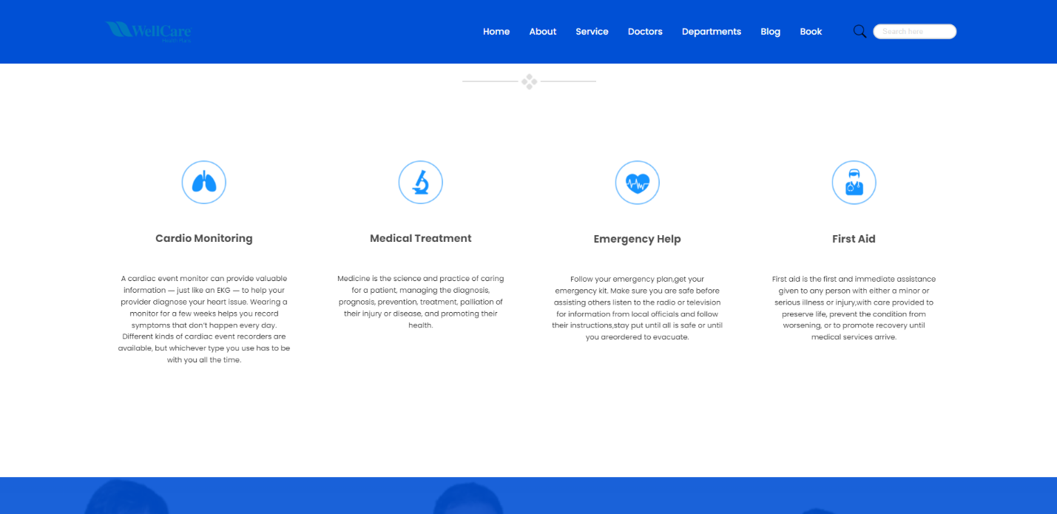

**4.Doctors page:**

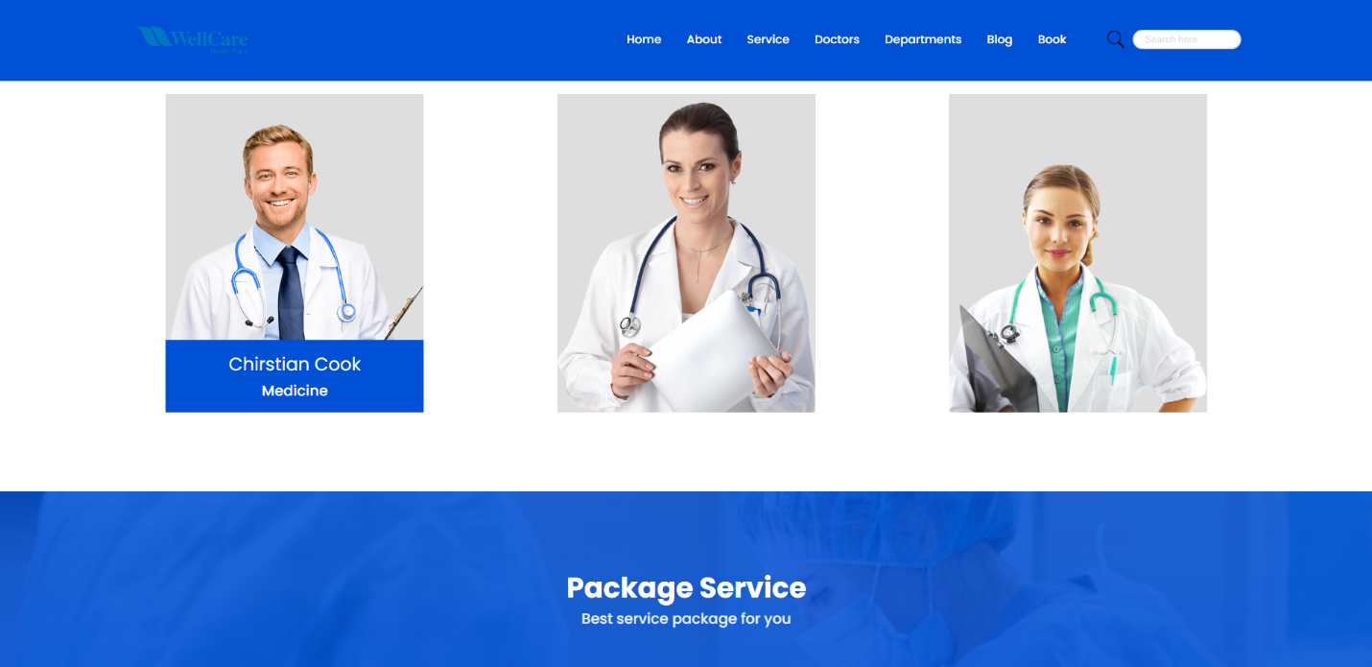

**5. Departments Page**:

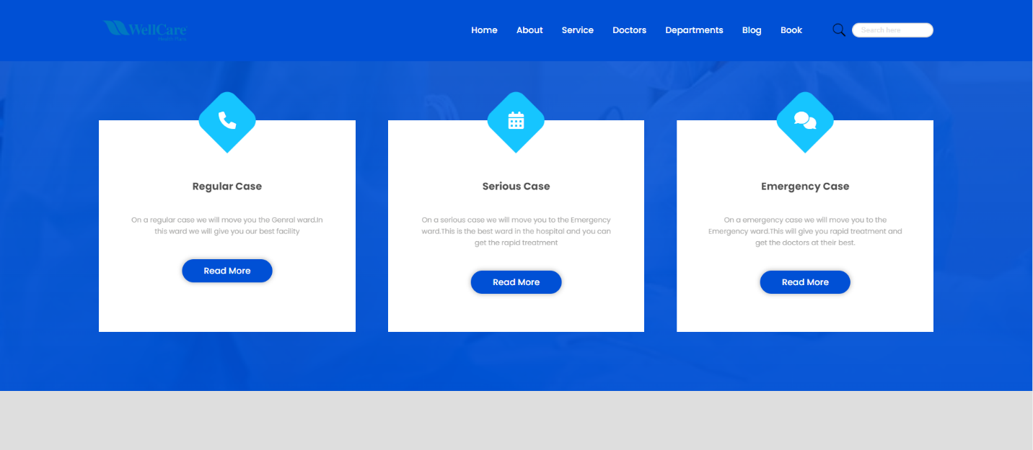

**6.Blog page:**

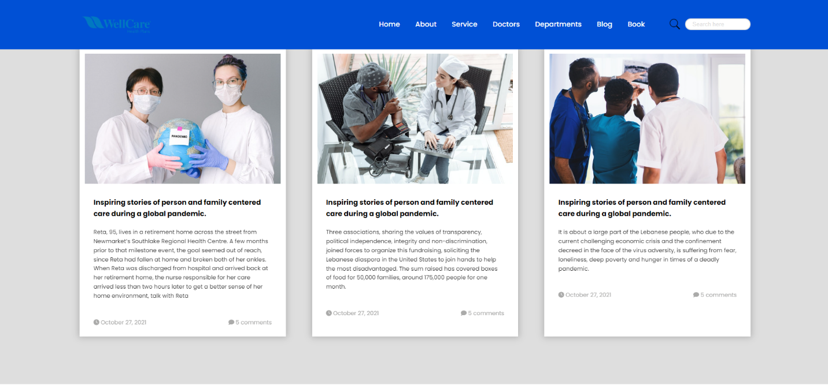

**7.Book page:**

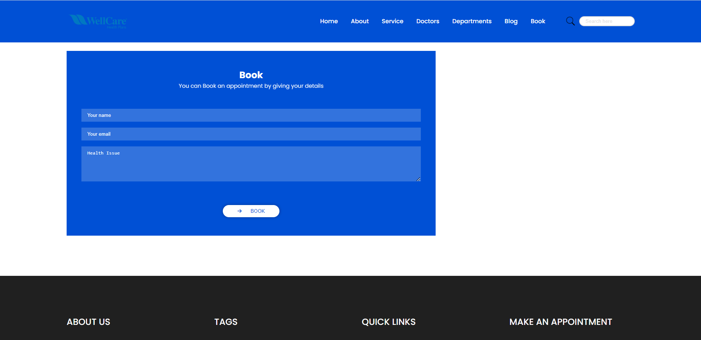

**5.About us Page:**

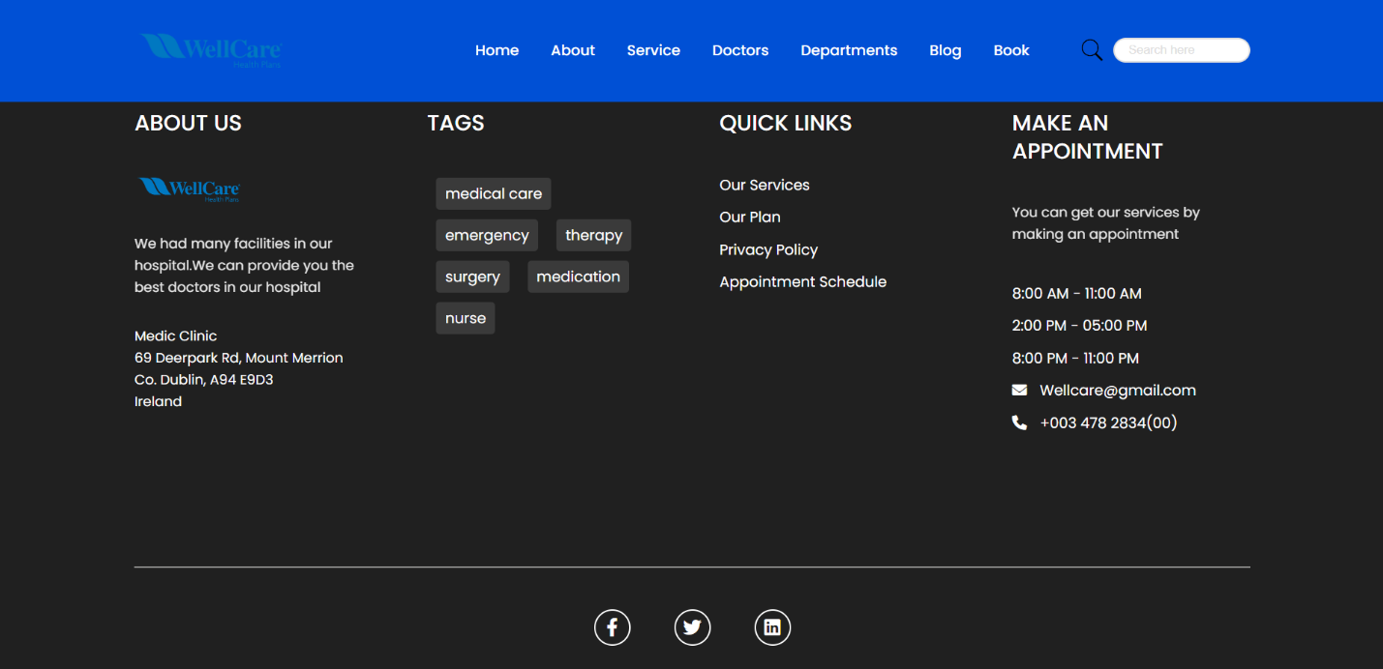

**MODULES:**

**PRODUCT CATALOGUE SECTION:**

The product catalog stands as a pivotal element within any online e-commerce store, serving as a digital showcase of the diverse range of products available.

An intelligently structured and visually engaging product layout is implemented to elevate the user experience, ensuring accessibility and optimal display across a spectrum of devices.

Products are systematically categorized, enabling users to effortlessly explore items based on their preferences. Utilizing high-quality images provides a visual representation, aiding users in making well-informed purchasing decisions. Clear and transparent pricing is displayed for each product, fostering a sense of trust and transparency.

Seasonal Collections: The product catalog allows for seamless updates to reflect seasonal trends and offerings, ensuring a dynamic and fresh array of items.

The product catalog section assumes a pivotal role in guiding users through their journey on an online e-commerce store. Through user-friendly design, comprehensive product information, and customization options, a thoughtfully curated catalog significantly contributes to customer satisfaction and active engagement.

PRODUCTS:

This section assists customers in discovering recommendations for popular products available across various stores within the "MDR Shops" network. This feature empowers users to select their preferred store for shopping, showcasing our top-selling items on the website. By highlighting our best-selling products, we aim to guide users in making informed choices and enhance their shopping experience.

SERVICES:

This section assists customers in discovering recommendations for popular products available across various stores within the "MDR Shops" network. This feature empowers users to select their preferred store for shopping, showcasing our top-selling items on the website. By highlighting our best-selling products, we aim to guide users in making informed choices and enhance their shopping experience.

REPORT ISSUE:

This dedicated section enables customers to report any issues encountered while navigating the online e-commerce store. From selecting products, placing orders, and tracking deliveries, customers can use this platform to communicate their concerns. Our goal is to promptly address these issues and ensure a seamless and satisfactory online shopping experience, from order placement to successful delivery.

CONTACT US:

This section provides customers with the opportunity to contact our customer care team, allowing them to communicate their issues and receive resolution within 24-48 hours. Similar to the Report Section, this area is designed to facilitate efficient problem-solving and enhance customer satisfaction.

FLOW OF PROJECT:

The project team embraced an agile development methodology, fostering collaborative efforts from each team member. Tasks were allocated based on individual expertise, and regular meetings were conducted to discuss progress, with scheduled reporting to prevent errors. The project development flow encompassed the following stages:

Planning:

Clearly define the scope, goals, and requirements of the project.

Prioritize creating a user-friendly online shopping platform.

Select a color scheme aligned with the overarching theme.

Development:

Simultaneously implement frontend functionalities to ensure a seamless shopping experience.

Testing:

Conduct thorough testing to identify and rectify any bugs or issues.

Manage the visual appearance of web pages by applying diverse combinations of codes and decorations.

Documentation:

Document the codebase, functionalities, and user guides for future reference and understanding.

This agile approach ensures a streamlined and efficient process for developing the online e-commerce platform, with a focus on user experience, functionality, and meticulous testing to deliver a reliable and visually appealing shopping website.

**Conclusion:**

The online e-commerce store emerges as a dynamic and indispensable platform in the contemporary retail landscape. Through this digital interface, users access a diverse range of products, leveraging a multitude of features crafted to elevate their overall shopping experience.

The user-friendly interface ensures smooth navigation, while account management functionalities enable personalized interactions. Robust product catalogs and well-organized sections provide users with a wide array of choices.

As the e-commerce industry evolves, adaptability to emerging trends such as augmented reality shopping, sustainable practices, and innovative payment methods becomes crucial for maintaining a competitive edge. Compliance with legal and ethical considerations ensures responsible and trustworthy services in accordance with local regulations.

In essence, the success of an online e-commerce store hinges on a thoughtful, user-centric design, and a commitment to meeting the diverse demands of modern consumers. As these platforms continue to refine and expand their offerings, they remain pivotal in shaping the ever-changing landscape of retail consumption.